JS-Control flows

**Date: 18-05-2024**

1. Write a program to check eligible to vote. (eligible to vote if age 18+)
   * age = 24;
   * **Display message: "You are eligible to vote"**
2. Write a program to check whether a given number is even or odd.
   * num = 27;
   * **Display message: "Number {num} is odd/ even"**
3. Write a program that displays the largest integer among two integers.
   * num1 = 10;
   * num2 = 2;
   * **Display message: "{num1} is large than {num2}"**
4. Write a program that determines if a year is a leap year.
   * year = 2024;
   * **Display message: "{year} is leap year"**
5. Write a program to check alphabet it is vowel or consonant using switch case.
   * alphabet = 'a';
   * **Display message: "{alphabet } is vowel/ consonant"**
6. Write a program to compute the sum of the first 10 natural numbers using a **for** loop.
   * **Display message: "The first {number} number's sum is {sum}."**
7. Write a program to print given shapes.
   * **For loop**

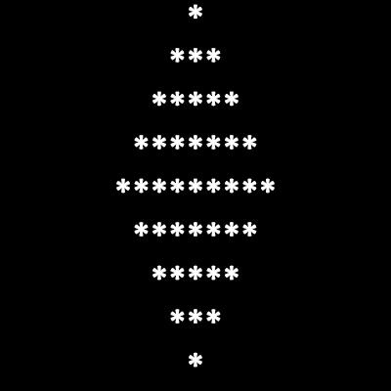

* + **while loop**

